# Activity System with editable text box labels

**Tools**

Add text here

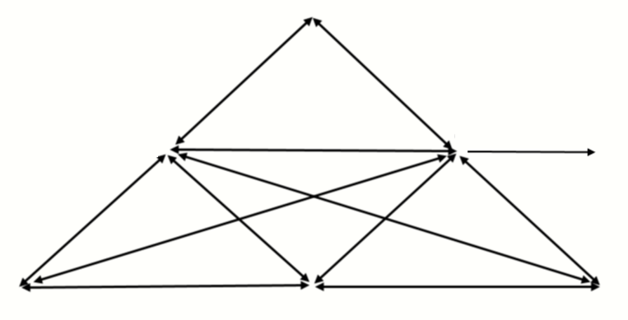

**Outcome**

Add text here

**Object**

Add text here

**Division of labour**

Add text here

**Community**

Add text here

**Rules**

Add text here

**Subject**

Add text here